AFS Saginaw Valley Chapter Foundry in a Box 2017-2018 events

Saturday, Sept 16, 2017
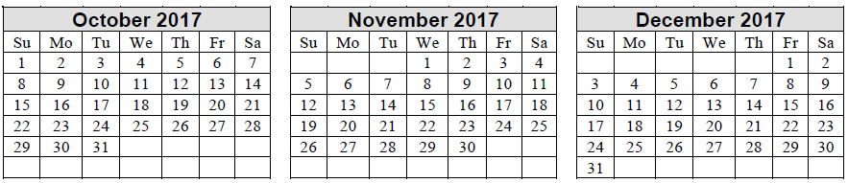
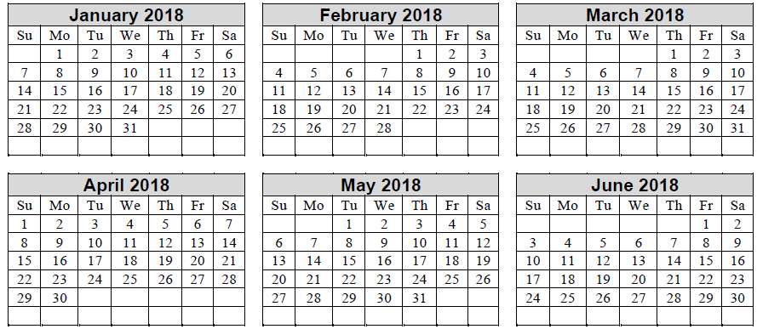

Confirmed date tentative date Easter is April 1 AFS Dinner meetings
SCHEDULED EVENTS:
Midland Rock Center for Youth Development Wed Jan 31, Tues Feb 6, Thurs Feb 8 (after school 2:45 -4:45 PM)
Northeast Middle School, Midland Thurs. Feb 8 (3 sessions 8:15 AM to 1:30 PM)
Lake Orion Girl Maker Faire (DTW primary) Saturday February 10, 2018 (8:30 AM – 2:30 PM)
Standish/Sterling Elementary Friday, March 9 (5th grade)
Hemmeter Elementary SPARK Friday April 13 7:30 -11:00 AM (5th graders)
Clarkston Maker Faire Saturday April 21, 2018 (8:00 AM – 4:30 PM)
St. Bartholomew, Kawkawlin Tuesday, April 24 1-2:30 PM (30 students)
GM GPS Pontiac Engine Design class Wednesday, May 9 – GM borrow kit, patterns – no volunteers needed
NCCE – Nouvel Catholic Central Elementary Friday, May 18

Au Gres Sims (Elementary Brandon Schnettler) 3rd-4th grade thru high school
Chestnut Hill Elementary School, Midland (Mike Schmitt)
Peace Lutheran School, Saginaw
Caseville schools grade 4-8 (did middle high school in 2017)
Freeland Elementary 4th and 5th graders?
Faith Lutheran Preschool and Childcare in Bridgeport (June)
COMPLETED EVENTS:
Saginaw Children’s Museum (Touch a Truck) Saturday, Sept. 16 (9:00 AM – 5:00 PM)
SciFest at Delta College Friday October 6th from 8:00 AM to 2:00 PM
SciFest at Delta College Saturday October 7th from 9:30 AM to 4:00 PM
Vassar Elementary Monday October 16 8:30 AM to 12 PM (3 morning sessions 5th graders)
Swartz Creek Elms Road Elem. (STEM) Monday, October 30, 8AM-12:45 PM (5 sessions of 4th & 5th 30 graders)
Delta Kelly Elementary, Rochester Hills Wednesday Nov 1 (4 sessions of 5th graders - 26 per class)
Handy Middle School, Bay City Wed, Nov 8, Tues Nov 28 7:30 AM – 2:30 PM (300+ 7th graders)
Western Middle School Bay City Wed Dec 13, Thurs Dec 21 7:00 AM – 230 PM (300 + 7th graders)
Owendale - Gagetown Tuesday, Dec. 19 10 AM to 3 PM (5th to12th grades)
Flushing Middle School Monday January 8 (4 sessions 26-30 7th to 8th grades) 10 AM to 3 PM
Haven Elementary, Saginaw Wednesday Jan. 17 8:45 AM-3:00 PM. (5 sessions 4th grades)
Haven Elem & Swan Valley Girl Scouts Wednesday Jan. 24 10:00 AM-4:30 PM. (4 sessions -5th gr & Girl Scouts)

