AFS Saginaw Valley Chapter Foundry in a Box 2018-2019 events

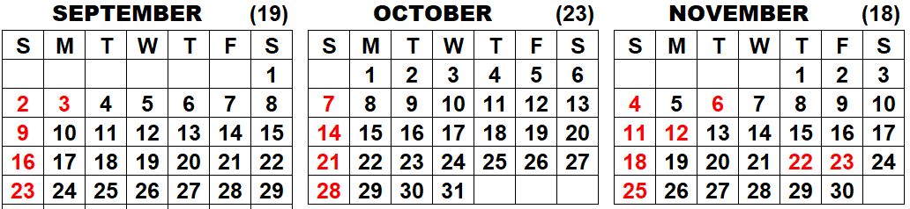
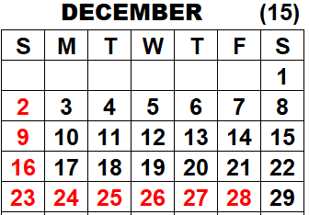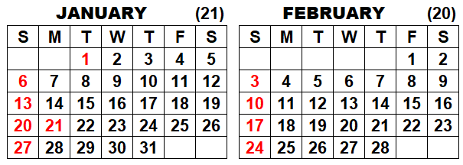
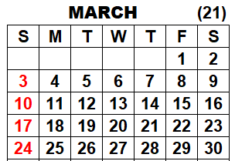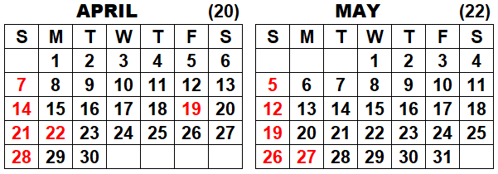
Confirmed date tentative date Easter is April 21, 2019

SCHEDULED EVENTS:
Vassar Elementary School Friday, October 26 for 5th grade classes from 8 AM to 11 AM
Bay City Handy Middle School Thursday Nov. 29, Wednesday Dec. 5 from 7:00 AM to 2:30 PM (7th graders)
Bay City Western Middle School Thursday Dec 13, Thurs. Dec. 20 from 7:00 AM to 1:30 PM (7th graders)
Haven Elementary, Swan Valley January (T or W) for 5 classes of 4th grade 25-27 youth
Lake Orion MakerFaire (assist DTW AFS) Saturday March 2, 2019
Hemmeter Elementary SPARK Friday May 10, 2019 from 8-11 AM
Clarkston MakerFaire Saturday, May 18, 2019 from 7:30 AM to 4:30 PM
Peace Lutheran, Saginaw Twp. TBD for 6-8th grades
Lapeer Michigan public schools TBD
Carrollton Public Schools TBD

COMPLETED EVENTS:
Saginaw Children’s Museum Saturday September 15
STEM Festival at Delta College Friday-Saturday October 12th and Saturday October 13th

